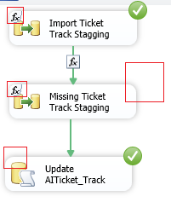

After running the first task, in another place, a variable **@DisableTask** is set to True



Then it will take the second task as disable, but it will continue the path

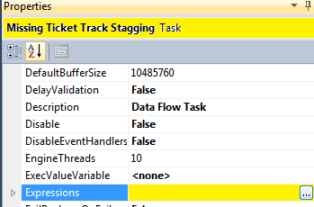

Evaluate variable

